Hi Team,

I have oracle XE Database running in my Machine.

I need to execute the following query

**select version from oms10.dcspp_order where version=17**

Can you please share the DB Query Monitor Plugin.

I have installed **dynatrace appmon and have trail license**

Followed the below mentioned steps.

1. [**https://github.com/Dynatrace/Dynatrace-AppMon-DB-Query-Monitor-Plugin**](https://github.com/Dynatrace/Dynatrace-AppMon-DB-Query-Monitor-Plugin)

From the above mentioned link have got the zipped content Dynatrace-AppMon-DB-Query-Monitor-Plugin-master and have attached the same

Installed the plugin by importing the jar **com.db.tabmon_3.2.3.jar**

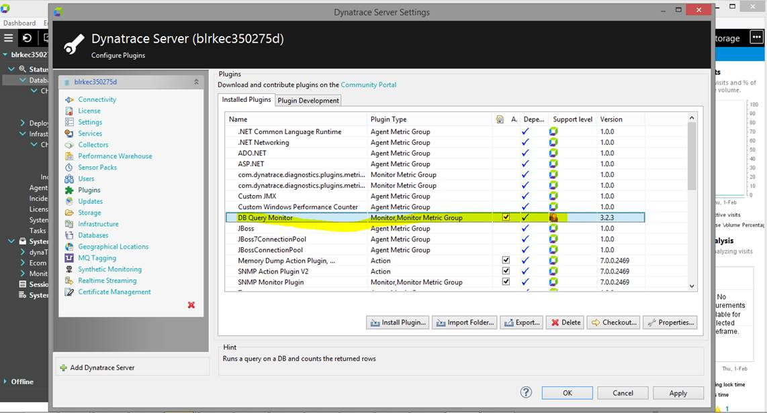

As highlighted in the below screenshot have mentioned the appropriate values. But I’m not getting hosts section as mentioned in the **Screenshot**

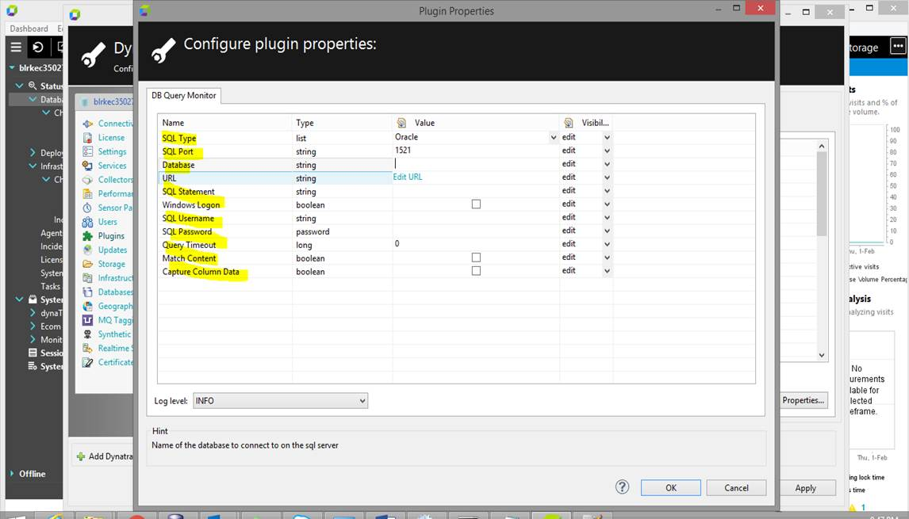

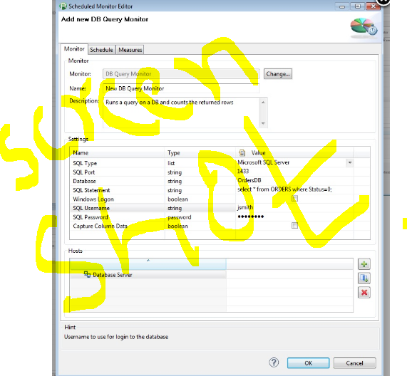

1. [**https://community.dynatrace.com/community/pages/viewpage.action?title=DB+Query+Monitor+Plugin&spaceKey=DL**](https://community.dynatrace.com/community/pages/viewpage.action?title=DB+Query+Monitor+Plugin&spaceKey=DL)

I got the JAR by name**com.db.tabmon_3.2.4.jar**

Installed as the plugin.

Here also same issue as first approach

Need your assistance badly.

Request you to help me on this ASAP